|  |  |
| --- | --- |
| **report-8 Wireless communications**   |  | | --- | | **Prof. Dr. Said E. El-Khamy  Communication & Electronics** | |
|  |

|  |
| --- |
| **Asmaa Gamal Abdel-Halem Mabrouk Nagy أسماء جمال عبد الحليم مبروك ناجي 15010473** |
| **Difference Between 5G & 6G -**  **OFDM-**  **Turbo Codes -** **AMC (Adaptive Modulation & Coding)**   |

**Difference Between 5G & 6G**

**5G Wireless**

The term 5G refers to fifth generation of wireless technology. With several years of research and testing 5G NR has been introduced recently in April, 2019. It precedes 4G LTE technology and follows same 3GPP roadmap. The specifications have been introduced from 3GPP Release 15 and Beyond.

There are different phases under which 5G NR (New Radio) will be deployed as per 3GPP specifications published in the december 2017. There are two main modes viz. Non-Standalone (NSA) and Standalone (SA) based on individual or combined RAT operation in coordination with LTE. In standalone mode, UE works by 5G RAT alone and LTE RAT is not needed. In non-standalone mode, LTE is used for control (C-Plane) functions e.g. call origination, call termination, location registration etc. where as 5G NR will focuse on U-Plane alone. The figure-1 depicts 5G NR architecture.

**Following are the features of 5G wireless technology.**  
• Bandwidth: Supports 1Gbps or higher  
• Frequency bands: Sub-1 GHz, 1 to 6 GHz, > 6 GHz in mm bands (28 GHz, 40 GHz), Refer [5G Bands>>](https://www.rfwireless-world.com/Tutorials/5G-frequency-bands.html).  
• Peak data rate: Approx. 1 to 10 Gbps  
• Cell Edge Data rate: 100 Mbps  
• End to End delay : 1 to 5 ms  
• Refer [5G Basic Tutorial](https://www.rfwireless-world.com/Tutorials/5G-tutorial.html) for more information on 5G wireless technology and its network architecture.

**6G Wireless**

The term 6G refers to sixth generation of wireless technology. It is proposed to integrate advanced features in the existing 5G technology to fulfill objectives at individual and group levels. Some of the 6G services include holographic communications, Artificial intelligence, high precision manufacturing, new technologies such as sub-THz or VLC (Visible Light Communications), 3D coverage framework, terrestrial and aerial radio APs to provide cloud functionalities and so on.

At the time of writing as on June 2019, 5G has been installed and tested in major cities of USA by Sprint, Verizon and T-mobile where as 6G wireless is undergoing research. Companies such as Samsung and SK Telecom have started research in 6G wireless technology domain. Moreover SK telecom has joined hands with Ericsson and [Nokia](https://www.rfwireless-world.com/Terminology/Difference-between-5G-and-6G.html) for research in 6G technology. 6G uses cell-less architecture in which UE connects to the RAN and not to a single cell.

**Following are the key technical features introduced in 6G wireless.**• New Spectrum : Due to increase in traffic demand and scarcity of spectrum resources THz (Terahertz) and Visible light bands have been introduced for communication in 6G mobile communication system.  
• New channel coding has been introduced based on Turbo, LDPC, Polar, etc.  
• Sparse theory (compressed sensing)  
• Very large scale antenna processing for THz  
• Advanced signal processing  
• Flexible spectrum (Full (free) spectrum, Spectrum sharing)  
• AI based wireless communication  
• Space-Air-Ground-Sea integrated communication  
• Wireless Tactile Network

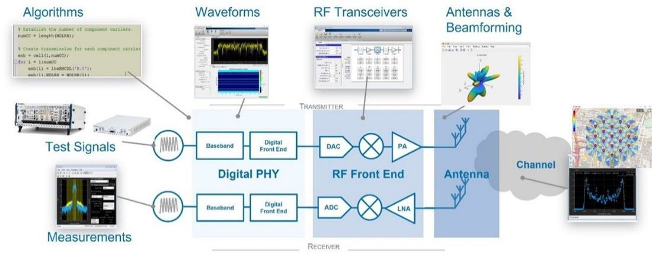

**6G Use Cases and Requirements**5G adoption is up and running around the world. However, the continuous convergence of the physical and the virtual world across many domains will further magnify performance requirements and push 5G to its limits in the long run. Therefore, the next-generation (6G) wireless systems will need to reach unprecedented service quality levels capable of satisfying a whole new class of applications and services for 2030 and beyond.

**6G will empower various technological advancements.**

Beyond improving on existing 5G use cases, some researchers envision that 6G will need to handle extremely demanding applications such as holographic communications, extended virtual reality (XR), massive digital twinning, and ultra-large-scale Internet of Things (IoT). Such use cases will generate massive amounts of data, require ultra-high bitrates at precise locations, and provide network efficiency clearly superior to what 5G can offer. Such applications will also require intelligence capabilities beyond 5G to enable real-time decision-making on high volumes of data.  
**6G applications** can be classified into different categories based on high-level functional and performance requirements. The focus of this white paper is on four categories:

* Networked-enabled robotic and autonomous systems: Applications where systems can perceive their surroundings using sensors and interact with humans in natural ways and make decisions necessary to assist or support a set of tasks. Applications include online cooperative operation among service robots and digital twins for manufacturing.
* Multisensory extended reality: Application for advanced virtual reality (VR) and augmented reality (AR) bringing highly immersive experiences with haptics, visuals, and audio, adapted to the environment. Applications include mixed-reality co-design and mixed-reality telepresence.
* Distributed sensing and communications: Use cases with massive sensor and data collection networks. Applications include in-body networks and immersive smart cities.
* Sustainable development and inclusive communication: Use cases in this category focus on reducing inequalities and achieving digital inclusion by ensuring global access to digital services. This includes remote medical services, expanded digital access, and additional educational resources in areas historically difficult to reach with wireless internet.

**5G Vs 6G | Difference Between 5G And 6G**

Following table compares 5G vs 6G with respect to various parameters and mentions tabular difference between 5G and 6G wireless technologies. The informations have been collected from various research conducted on 5G and 6G areas across the globe.

|  |  |  |
| --- | --- | --- |
| Features | 5G | 6G |
| Frequency Bands | • Sub 6 GHz, • mmwave for fixed access | • Sub 6 GHz, • mmwave for mobile accessm exploration of THz bands (above 140 GHz), • Non-RF bands (e.g. optical, VLC) etc. |
| Data rate | 1 Gbps to 20 Gbps (Downlink Data Rate - 20 Gbps, Uplink Data Rate - 10 Gbps) | 1 Tbps |
| Latency (End to End Delay) | 5 ms (Radio : 1 msec) | < 1 ms (Radio : 0.1 msec) |
| Architecture | • Dense sub 6 GHz smaller BSs with umbrella macro BSs • Mmwave small cells of about 100 meters (for fixed access) | • Cell free smart surfaces at high frequencies (mmwave tiny cells are used for fixed and mobile access) • Temporary hotspots served by drone mounted BSs or tethered Balloons. • Trials of tiny THz cells (under progress) |
| Application types | • eMBB (Enhanced Mobile Broadband) •  URLLC (Ultra Reliable Low Latency Communications) •  mMTC (Massive Machine Type Communications) | • MBRLLC •  mURLLC •  HCS •  MPS |
| Device types | • [Smartphones](https://www.rfwireless-world.com/Terminology/Difference-between-5G-and-6G.html) • Sensors •  Drones | • Sensors & DLT devices •  CRAS •  XR and BCI equipment •  Smart implants |
| Spectral and energy efficiency gain | 10 x in bps/Hz/m2 | 1000 x in bps/Hz/m3 |
| Traffic Capacity | 10 Mbps/m2 | 1 to 10 Gbps/m2 |
| Reliability | 10-5 | 10-9 |
| Localization precision | 10 cm on 2D | 1 cm on 3D |
| User experience | 50 Mbps 2D everywhere | 10 Gbps 3D everywhere |

Conclusion: The goal of 6G technology is to fulfill vision of 5G technology and in addition to meet Wisdom connection, Deep connectivity, Holographic connectivity and Ubiquitous connectivity. 5G accommodates different types of networks where as 6G aggregates them dynamically.

**OFDM**

Orthogonal frequency-division multiplexing (OFDM) is a digital communication technique initially developed for use in cable television systems. OFDM is similar to the broadcasting technique known as frequency division multiplexing (also known as FDM), which uses a multitude of transmitters and receivers to send information on different frequencies over a single wire, such as an electrical power cable.

The first use of OFDM was by Bell Labs in 1984, and it has since become widely used in wireless applications such as mobile telephony and broadband communications. In wireless communications, OFDM has become an alternative to single-carrier modulation techniques such as frequency division multiple access (FDMA), time-division multiple access (TDMA), and code-division multiple access (CDMA). It is used in applications including digital video broadcasting, digital audio broadcasting, digital cable television, and orthogonal frequency division multiplexing line (OFDML) as well as ADSL.

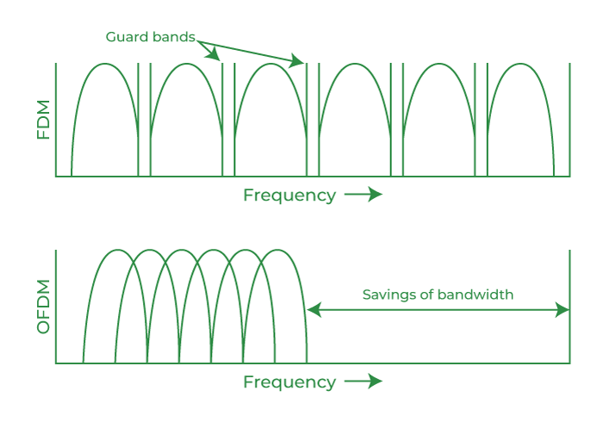

In digital wireless systems, M-ary OFDM, or 2 M-ary OFDM (M=2) is used to carry the data streams of multiple users. In an M-ary system, the spectrum is divided into a set of Sub-bands such that each Sub-bands is orthogonal. For example, in an 8 MHz bandwidth system, the spectrum may be split into eight 1 MHz Sub-bands.

These eight sub-bands are typically assigned to individual channels (digital ‘sub-channels’), but they can also be used to encode data streams from several users (analog ‘sub-carriers’).

In communication systems, OFDM has become an alternative to single-carrier modulation techniques such as frequency division multiple access (FDMA), time-division multiple access (TDMA), and [code-division multiple access](https://www.geeksforgeeks.org/cdma-full-form/) (CDMA).

**Uses of OFDM:**

OFDM is used in Digital radio, Digital Radio Mondiale, digital audio broadcasting, and satellite radio.

OFDM is used in Wired data transmission, Asymmetric Digital Subscriber Line (ADSL), Institute of Electrical and Electronics Engineers (IEEE) 1901 powerline networking, and cable internet providers.

M-ary Amplitude shifting:

Multilevel (M-ary) amplitude shift coding (ASK) transmits a symbol representing N=log 2 M bits of information. A signal by Mary Ask Keep the carrier’s frequency in one of the discreet levels during the time of the symbol Ts for the representation of n = log 2 m logical track signals for the transmission of information.

Encoding M-ary OFDM is difficult. If the system must transmit a single stream, it can use SSB modulation, but this requires precise synchronization of all Sub-carriers.

It cannot use simple equalizers because each subcarrier has its own frequency offset. As a result, the rejection can occur due to echo off adjacent Sub-carriers that have different frequencies. It is thus important to mitigate the effect of inter-carrier interference by synchronous detection and correction.

**MATLAB PLOTS**

* OFDM signal

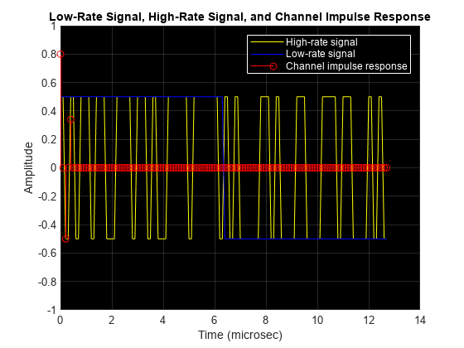

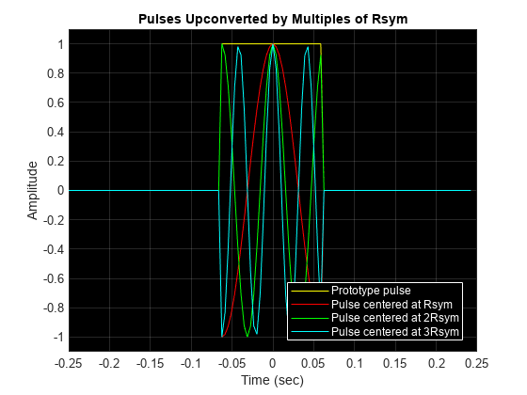

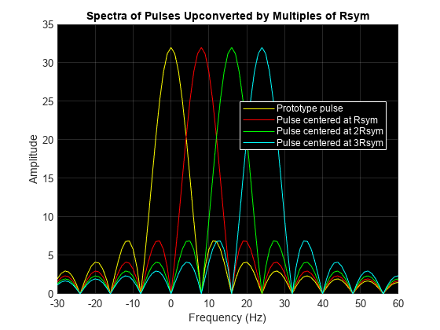

An OFDM modulator sums all these subcarriers together to form its output signal. Here, the subcarriers are baseband modulated using the QAM-method. Mathematically, the sampled modulator output signal *s*(*k*) is given by

*s*(*k*)=*N*−1∑*m*=0*am*,*n* *e*j2*πmR*sym*k*(*T*sym*N*),

where

* *am*,*n* is a QAM-modulated symbol of the *m*th subcarrier in the *n*th OFDM time symbol
* *R*sym is the symbol rate of each of the low-rate QAM streams
* *T*sym=1 / *R*sym
* *N*is the number of subcarriers, or low-rate QAM streams

This equation simplifies to

*s*(*k*)=*N*−1∑*m*=0*am*,*n* *e*j2*π*(*m* *kN*),

which is a scaled version of the inverse discrete Fourier transform (IDFT) of the QAM symbol stream *am*,*n*.

* **Basic OFDM with No Cyclic Prefix**

OFDM simultaneously transmits closely spaced orthogonal subcarrier signals of overlapping sinusoids. Transmission data is first coded and modulated, typically into QAM symbols. These symbols are loaded into equally spaced frequency bins and then an inverse fast Fourier transform (IFFT) is applied to transform the signal into orthogonal overlapping sinusoids (subcarriers) in the time domain. Because the individual subcarriers are narrowband and experience flat fading, the receiver side equalization requires just one tap per subcarrier.

Create a simple OFDM system, using the single-carrier 16QAM signal as the OFDM modulator input. A stem plot shows that all frequency bins contain data.

Code:

bps = 4; % Bits per symbol

M = 2^bps; % 16QAM

nFFT = 128; % Number of FFT bins

txsymbols = randi([0 M-1],nFFT,1);

txgrid = qammod(txsymbols,M,UnitAveragePower=true);

txout = ifft(txgrid,nFFT);

stem(1:nFFT,real(txout))

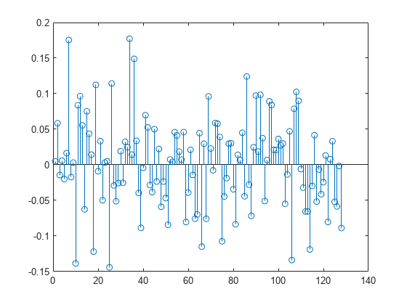

Filter the transmission data through an AWGN channel with minimal noise. OFDM reception reverses the transmission processing. Apply an FFT and QAM demodulation, and then confirm that the received symbols match the transmitted symbols.

 Code:

rxin = awgn(txout,40);

rxgrid = fft(rxin,nFFT);

rxsymbols = qamdemod(rxgrid,M,UnitAveragePower=true);

if isequal(txsymbols,rxsymbols)

disp("Recovered symbols match the transmitted symbols.")

else

disp("Recovered symbols do not match transmitted symbols.")

end

Recovered symbols match the transmitted symbols.

All bins of the IFFT are filled with data for this transmission. In practical systems, edge bins are often left empty to serve as guard bands, and some bins can be used to send specific pilot signals. The combination of guard band and pilot signals helps with synchronization and equalization.

**Turbo Codes**

Turbo coding is a powerful error correction technique used in digital communication systems to improve the reliability of data transmission over noisy or error-prone channels. It was introduced in the early 1990s and has since become a key component of many modern communication standards, including 3G and 4G cellular networks, satellite communication systems, and digital television broadcasting. Here's an overview of turbo coding:

**Principle:**

Turbo coding employs parallel concatenated convolutional codes (PCCC) or parallel concatenated recursive systematic convolutional codes (PRSCC).

It utilizes multiple convolutional encoders and an interleaver to generate redundant bits, which are added to the original data stream to create a coded sequence.

At the receiver, iterative decoding algorithms, such as the turbo decoding algorithm or the max-log-MAP (maximum a posteriori) algorithm, are used to iteratively estimate the original data from the received noisy sequence.

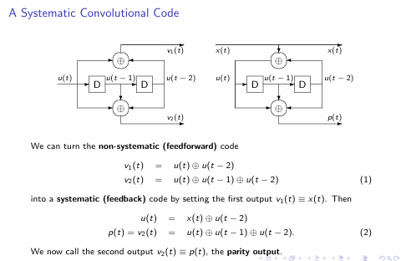

**Iterative Decoding:**

Turbo decoding involves multiple iterations between the constituent decoders, typically using the so-called turbo decoding algorithm.

In each iteration, one decoder uses soft input information from the other decoder to improve its estimates of the transmitted data.

The process continues for several iterations, with each iteration refining the estimates until a satisfactory level of reliability is achieved.

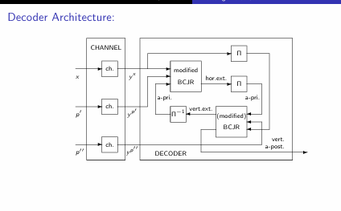

**Performance:**

Turbo codes offer near-optimal performance in terms of error correction capability, approaching the Shannon limit for additive white Gaussian noise (AWGN) channels.

They provide significant coding gain over simpler error correction codes like Reed-Solomon codes or convolutional codes, especially at moderate to high signal-to-noise ratios (SNRs).

**Applications:**

Turbo coding is widely used in digital communication systems where reliable data transmission is critical, such as wireless communication standards (e.g., 3G, 4G, and 5G), satellite communication systems, and digital broadcasting.

It is also employed in deep-space communication systems, where the channel conditions are extremely challenging due to long propagation distances and weak received signals.

**Implementation:**

Turbo coding algorithms can be implemented in hardware, software, or a combination of both.

Dedicated turbo decoder chips are available for high-throughput applications, while software-based implementations are more flexible and can be easily adapted to different communication standards.

Overall, turbo coding is a sophisticated error correction technique that significantly improves the reliability of data transmission over noisy communication channels. Its near-optimal performance, combined with efficient implementation options, makes it an indispensable component of modern digital communication systems.

Unpuncture turbo code driver for multiple runs

**Unpuncture turbo code driver for multiple runs:**

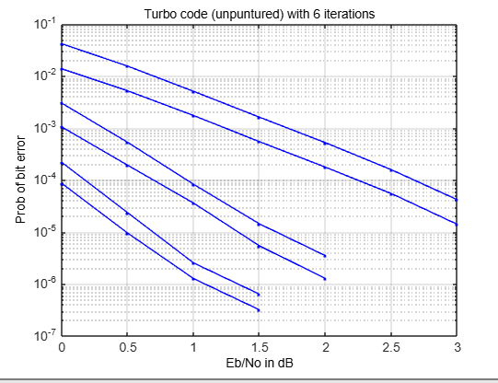

% Unpuncture turbo code driver for multiple runs

% script to invoke the SIMULINK Turbo code model

% Revised 8/24/2011

% In Soo Ahn, Dept. of ECE, Bradley University

% calculate the BERs under different Eb/No's.

clear all

close all

MaxdB = 3.0; % maximum Eb/No in dB for simulation

EbNo_incr = 0.5; % Eb/No increment in dB

No_pts = MaxdB/EbNo_incr; % number of points for EbNo plot

Iter = 6; % number of iterations

%trellis = poly2trellis(3, [7 5],7);

trellis = poly2trellis(5, [37 21],37);

code_rate = 1/3;

multiplier = 1/code_rate; % multiplier = symbol_period/sample_time

% you can change this to other trellis.

Len = 1024*1024;

% size of interleaver, try a smaller or larger size.

Turbo_Pb = zeros(Iter,No_pts); % allocate the storage

Seed = 54123;

Ps = 1; % signal power

for i = 1:No_pts+1,

EbNodB = EbNo_incr*(i-1); % in dB

EbNo = 10.0.^(0.1*EbNodB);

EsNo = EbNo/code_rate; % Average symbol energy vs Noise PSD in linear scale

Variance = Ps*multiplier/EsNo; % Calculate channel noise variance. See Help of AWGN

sim('turbo_code_no_punc_multiple_run'); % open the simulink model.

Turbo_Pb(:, i) = bit_error_rate.signals.values(:,:,4);

end

%% Turbo_Pb can be plotted for the probability of bit errors.

x_index = (0:No_pts)*EbNo_incr;

figure(1)

for i = 1:Iter,

semilogy(x_index, Turbo_Pb(i,:), '.-');

hold on;

end

grid, xlabel('Eb/No in dB'), ylabel('Prob of bit error')

title('Turbo code (unpuntured) with 6 iterations')

**Puncture turbo code driver for multiple runs:**

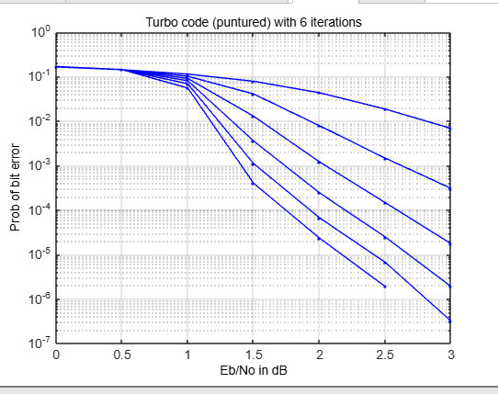

% Puncture turbo code driver for multiple runs

% script to invoke the SIMULINK Turbo code model

% Revised 8/24/2011

% In Soo Ahn, Dept. of ECE, Bradley University

% calculate the BERs under different Eb/No's.

clear all

close all

MaxdB = 3.0; % maximum Eb/No in dB for simulation

EbNo_incr = 0.5; % Eb/No increment in dB

No_pts = MaxdB/EbNo_incr; % number of points for EbNo plot

Iter = 6; % number of iterations

%trellis = poly2trellis(3, [7 5],7);

trellis = poly2trellis(5, [37 21],37);

code_rate = 1/3;

multiplier = 1/code_rate; % multiplier = symbol_period/sample_time

% you can change this to other trellis.

Len = 1024*1024;

% size of interleaver, try smaller or larger size.

Turbo_Pb = zeros(Iter,No_pts); % allocate the storage

Seed = 54123;

Ps = 1; % signal power

for i = 1:No_pts+1,

EbNodB = EbNo_incr*(i-1); % in dB

EbNo = 10.0.^(0.1*EbNodB);

EsNo = EbNo/code_rate; % Average symbol energy vs Noise PSD in linear scale

Variance = Ps*multiplier/EsNo; % Calculate channel noise variance. See Help of AWGN

sim('turbo_code_punc_multiple_run'); % open the simulink model.

Turbo_Pb(:, i) = bit_error_rate.signals.values(:,:,4);

end

%% Turbo_Pb can be plotted for the probability of bit errors.

x_index = (0:No_pts)*EbNo_incr;

figure(2)

for i = 1:Iter,

semilogy(x_index, Turbo_Pb(i,:), '.-');

hold on;

end

grid, xlabel('Eb/No in dB'), ylabel('Prob of bit error')

title('Turbo code (puntured) with 6 iterations')

**AMC (Adaptive Modulation & Coding)**

Adaptive Modulation and Coding (AMC) is a dynamic technique utilized in wireless communication systems to optimize data transmission parameters based on varying channel conditions. Here are key aspects of AMC:

* **Principle:**
* AMC dynamically adjusts modulation schemes and coding rates to maximize spectral efficiency and reliability over changing channel conditions.
* It employs sophisticated rate adaptation algorithms that consider factors such as channel quality, available bandwidth, error rates, and Quality of Service (QoS) requirements.
* **Modulation and Coding Schemes (MCS):**
* Modulation schemes such as Quadrature Amplitude Modulation (QAM) or Phase Shift Keying (PSK) vary in their efficiency and robustness under different channel conditions.
* Coding rate determines the amount of redundancy added to the data, affecting error resilience and data rate.
* **Rate Adaptation Algorithms**:
* Rate adaptation algorithms dynamically select the optimal MCS and coding rate based on channel measurements, feedback from the receiver, and system constraints.
* Common algorithms include proportional fair scheduling, exponential backoff, and throughput-based adaptation.
* **Trade-offs:**
* AMC involves trade-offs between data rate, reliability, and spectral efficiency.
* Higher-order modulation and lower coding rates offer higher data rates but are more error-prone, while lower-order modulation and higher coding rates provide better error resilience but result in lower data rates.
* **Feedback Mechanisms:**
* Accurate feedback from the receiver to the transmitter is crucial for AMC operation.
* Feedback mechanisms include Channel State Information (CSI) reporting, Signal-to-Noise Ratio (SNR) measurements, and acknowledgment (ACK/NACK) messages.
* **Channel Prediction:**
* Advanced AMC techniques may incorporate channel prediction algorithms to anticipate future channel conditions based on past observations.
* By predicting changes in channel quality, the transmitter can proactively adjust modulation and coding parameters to maintain optimal performance.
* **Cross-Layer Optimization:**

AMC is often part of a broader cross-layer optimization approach, considering information from multiple protocol layers to optimize resource allocation and transmission parameters.

* **Hybrid AMC:**

Hybrid AMC schemes combine adaptive modulation and coding with other transmission techniques, such as spatial diversity (MIMO) or beamforming, to further enhance system performance.

* **Dynamic Spectrum Access:**

In dynamic spectrum access (DSA) systems, AMC enables opportunistic spectrum utilization while mitigating interference with primary users.

Adaptive Modulation and Coding plays a pivotal role in modern wireless communication systems, enabling efficient and reliable data transmission over dynamic and heterogeneous wireless channels. Its continuous evolution and integration with other advanced techniques contribute to the enhancement of wireless network performance and the delivery of high-quality communication services.

**Adaptive Modulation and Coding (AMC) and switching point between STBC 2x2 and SM 2x2:**

